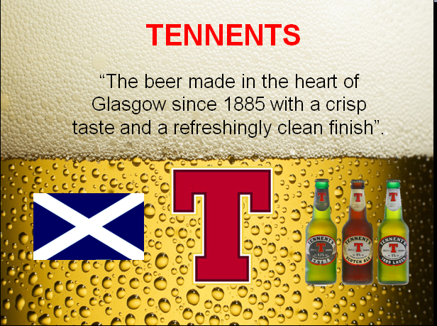

I’m here to present you the most famous product of the C&C Group; I’m talking about Tennents beer. “The beer made in the heart of Glasgow since 1885 with a crisp taste and a refreshingly clean finish.
They have quality products because of the traditional production methods we use.
Tennents is elaborated with the highest standards to create a lager with a fabulous taste. Let me inform you about how the production process is.
- The process begins with a mix of our two malts, lager and Munich.
- A hammer mills the malts, the barley and the maize into powder.
- Then water is added to the milled grain. And it is kept at a temperature of 65 or 66 degrees. Here is when the starch content converts into sugar.
- Later in a big kettle, hops are added to rich a balance of bitter and sweet.
- This mash is put under pressure to separate the grain from the liquid. Grains aren’t waste, they are used to feed the animals in the farm. As you can see they are an ecofriendly company.
- Then the wort is boiled again, to separate any solid and then it’s chilled to 10 degrees. Here is when yeast is added to convert sugars into alcohol.
- Five or seven days later, we add water to reduce the concentration.

The lager is packaged as cans or kegs. Our canning line runs up to 2000 cans per minute and over 750 barrels per hour.
If you aren’t convinced yet about collaborating with them, let me give you some extra information of the company, especially about the marketing and the export area.

Tennents has been exporting since the 19th century and it was the world’s greatest exported bottled beer.
Tennents Original Export has develop the design, the packaging and created the iconic “Red T” to enhance sales.
They have a very good brand image thanks to the marketing we made. They sponsor music festivals, the Scottish Football Cup, some football teams, snooker championship…
As you could see they do things well. Do you want to join them? I think it’s a good business, don’t you think that?




